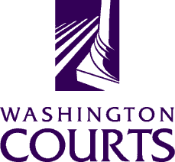

June 19, 2018

TO: Judges, Commissioners, County Clerks, Court Administrators, Libraries, Attorneys, and Public

FROM: Merrie Gough, AOC Sr. Legal Analyst

SUBJECT: June 2018 Summary of Changes to Title 11 RCW Guardianship forms

The Washington Pattern Forms Committee enhanced the Title 11 RCW Guardianship forms by adding two new recommended forms to the “Miscellaneous” category:

WPF GDN 07.0230 | Notice of Change of Address
WPF GDN 07.0770 | Notice of Substantial Change in Circumstances

The forms are available to download at: https://www.courts.wa.gov/forms/?fa=forms.contribute&formID=93.

